Truman Forey
CSD-380
7/20/2025
Shared Code Repository – Git Exercise
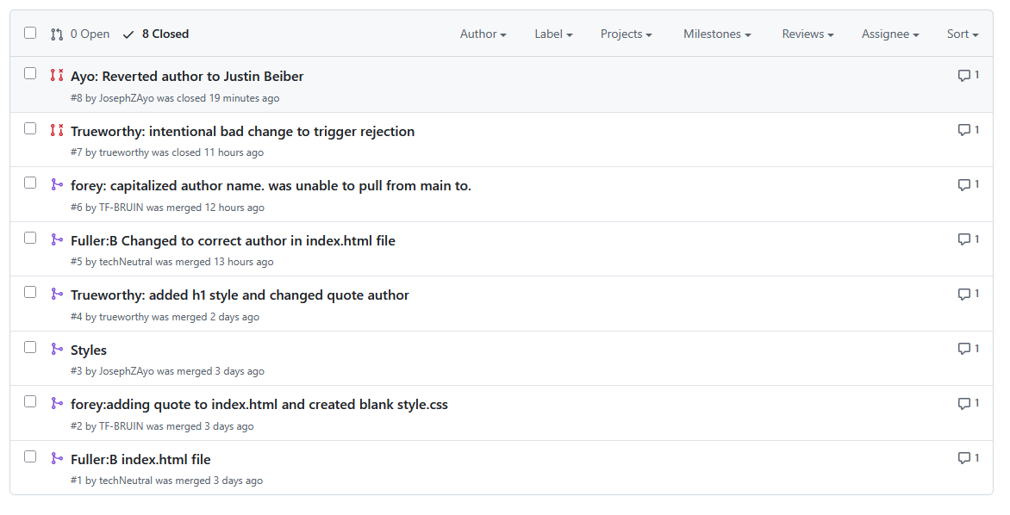
Git Username: https://github.com/TF-BRUIN
https://github.com/Pandma13/GitLab

